Name Surname: Furkan Özer Date:31/10/2025
Number:2023555067 Report No:01
Digital Design Lab Report
Homework / Lab
Parts of Report:
- Description: Design a or gate with VHDL codes. Explain how to make compilation and simulation in Modelsim. Show the simulation results.

- Truth Table of Design

A (input) | B (input) | C (output)
1 | 0 | 1
0 | 1 | 1
0 | 0 | 0
1 | 1 | 1

- Drawing the circuit of desired desing

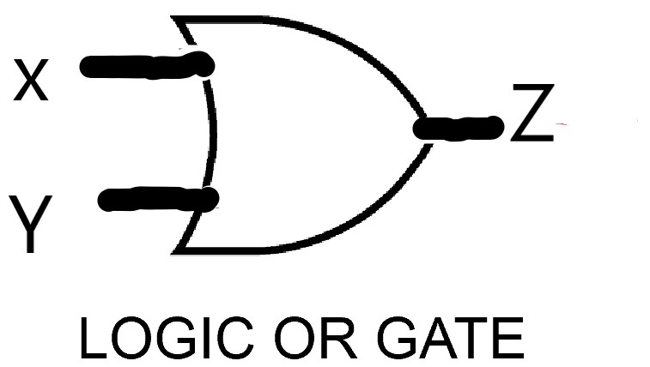
- Steps of Lab/Homework:
library IEEE;
use IEEE.std_logic_1164.all;

entity or_gate is
port (
x:in std_logic ;
y:in std_logic ;
z:out std_logic);
end or_gate;

architecture mimari of or_gate is
begin
process (x,y) is
begin
z<=x or y;
end process;
end mimari;

- Simulation Results:

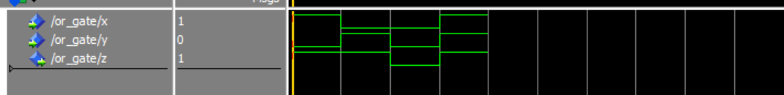

6)Conclusion:The designed VHDL code successfully implements the OR logic gate.According the simulation results,the output “Z” becomes 1 when either input X or Y and only becomes “0” when both inputs are 0.So, the obtained truth table matches the expected truth table of an OR gate.

